Gilbert Guyah

IST 719

Work-In-Progress Report

Overweight and Obesity

DATASET DESCRIPTION:

Behavioral Risk Factor Surveillance System (BRFSS) Prevalence Data (2011 to present) published Centers for Disease Control and Prevention with 27 Columns and 47K Rows of data. It contains combination of land line and cell phone prevalence data. BRFSS is a continuous, state-based surveillance system that collects information about modifiable risk factors for chronic diseases and other leading causes of death.

COMPELLING STORY:

Obesity in the United States is a major health issue resulting in numerous diseases, specifically increased risk of certain types of cancer, coronary artery disease, type 2 diabetes, stroke, as well as significant increases in early mortality and economic cost. The national adult obesity rate has increased by 26 percent since 2008.

AUDIENCE:

All citizens who are concerned with the apparent health risk with the increase rate of Obesity across the US.

QUESTIONS:

* **What is the BMI between being obese and being overweight by adults/male & female?**
* BMI is 18.5 to <25, it falls within the normal.
* BMI is 25.0 to <30, it falls within the overweight range.
* BMI is 30.0 or higher, it falls within the obese range.
* **Who is affected?**
* **The States with highest rate of obesity between, groups (Gender, Race)?**
* **What is the rate of increase in child obesity and by age group and state?**

DATA SOURCE:

<https://chronicdata.cdc.gov/Behavioral-Risk-Factors/Behavioral-Risk-Factor-Surveillance-System-BRFSS-H/iuq5-y9ct>

<http://www.cdc.gov/brfss>

Racial and ethnic disparities in overweight also exist among children, with black and Hispanic youth having the highest rates. By 1998, more than 22 percent of black and Hispanic children were overweight, while only 12 percent of white children were overweight.

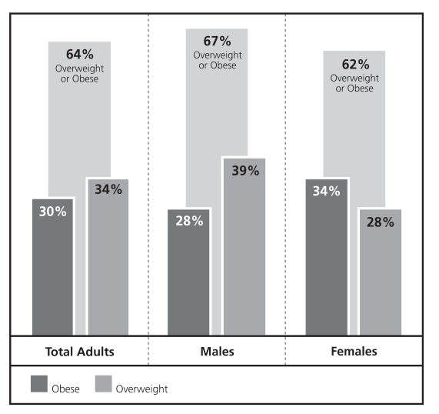

Obesity has increased in every state, in both sexes, and across all age,race, and socioeconomic groups. No region in the United States is im-mune to the obesity epidemic. During the 1990s, every state saw an in-crease in the prevalence of obesity among adults. Twenty-two states hadrates of obesity of 20 percent or greater in 2000, compared with none in1991. The states with the highest rates of obese residents include Missis-sippi (24 percent), Louisiana (23 percent), and West Virginia (23 percent).4Although men are more likely to be overweight than women, women aremore likely to be obese. Among both men and women, the prevalence ofoverweight and obesity increases with advancing age, until about age 69,after which it starts to decline. However, during the past decade, the sharp-est increase (70 percent) in rates of overweight and obesity occurred amongadults ages 18 through 29.

**Increase of Overweight and Obesity**

The national adult obesity rate has increased by 26 percent since 2008 and is a major health issue resulting in numerous diseases, specifically increased risk of certain types of cancer, coronary artery disease, type 2 diabetes, stroke, as well as significant increases in early mortality and economic cost.

US Map depicting obesity by States

**Question 1**

Who is affected?

What is the BMI between being obese and being

overweight by adults/male & female?

➢BMI is 18.5 to <25, it falls within the normal.

➢BMI is 25.0 to <30, it falls within the overweight range.

➢BMI is 30.0 or higher, it falls within the obese range.

**Question 2**

The States with highest rate of obesity between,

groups (Gender, Race)?

**Question 3**

What is the rate of increase in child obesity and

by age group and state?

|  |  |
| --- | --- |
| DATASET | * Behavioral Risk Factor Surveillance System (BRFSS) Prevalence Data (2011 to present) published Centers for Disease Control and Prevention with 27 Columns and 47K Rows of data. It contains combination of land line and cell phone prevalence data. BRFSS is a continuous, state-based surveillance system that collects information about modifiable risk factors for chronic diseases and other leading causes of death. |